Come fly with me!

*Book your own trip to the United Kingdom!*



Travel Agency name:………………………………………………

Group Members:

1. Sifra………………………Class: T3A
2. Luna………………………Class: T3A

The assignment

Dag allemaal,

De bedoeling van het project is, dat jullie in alleen of met z’n tweeën, een reis gaan uitstippelen voor twee personen. De reis gaan jullie uitzoeken op Engelse websites van de aangegeven vliegtuigmaatschappijen, hotels met Engels ontbijt en je zoekt 6 activiteiten voor de reis. Zorg dat de tijd van de vlucht en de datum op elkaar aansluiten, dus dat beide aankomstdagen hetzelfde zijn. Jullie krijgen hiervoor een bepaald bedrag waar je **niet** overheen mag! De duur van de reis is een mid-week, dus 5 dagen.

Jullie geven voorbeelden en bewijs van de opgezochte informatie via print screen. Deze print screen plakken jullie achter de juiste opdracht (vluchten bij opdracht vliegtuigmaatschappijen ect.) Je begint met het invullen van het samenwerkingscontract en het verdelen van de taken bij het kopje takenverdeling. Van daar uit werk je het boekje door. Als je alleen werkt, schrijf je een plan van aanpak wanneer je wat gaat doen.

Uiteindelijk lever je het boekje in bij de docent en presenteer je de reis voor de klas met een PowerPoint.

**Hoe is dit project verdeeld?**

*Les 1: Korte introductie van je docent over de opdracht. Vervolgens ga je met jullie*

*groep aan de slag met het projectboekje. Je gaat beginnen met een*

*plan van aanpak maken, de taken verdelen en een start met de opdrachten.*

*Les 2: Opzoeken van informatie/verder werken aan de opdrachten.*

*Les 3: In deze les gaan jullie de presentatie in elkaar zetten, je maakt gebruik van een*

*PowerPoint of Prezi.*

*Hierna volgen de PRESENTATIES!*

*De presentatie is minimaal 3 minuten, maximaal 6. Als je met twee personen bent, verdeel je de presentatie evenredig.*

*In je presentatie staan (minimaal) de vluchten, het hotel en de activiteiten.*

*Aan het einde van de les vullen jullie de evaluatie in.*

|  |
| --- |
| **INFORMATIE MET BETREKKING TOT DE REIS**  **De reis wordt geboekt op een maandag en de terugvlucht op vrijdag:**   * 17 oktober t/m 21 oktober 2016 * 24 oktober t/m 28 oktober 2016   **Het bedrag dat jullie krijgen om uit te geven is:**   * **€ 2000,-**   **Aantal dagen:**   * Mid-week, dus 5 dagen * 4 overnachtingen |

Samenwerkingscontract groep

**Namen + Mail adressen:**

Sifra: sifra.burger @gmail.com

Luna: luna.dejong@hotmail.com

**Groepsregels:**

***Wat doen jullie bij afwezigheid of ziekte van jullie groepsgenoot of jezelf?***

Working further, and if it doesn’t work we can e-mail eachother or ask the teacher.

***Wat doe je bij onenigheid/ruzie in jullie groepje?***

We will talk about it.

***Hoe gaan jullie het werk verdelen? (+tijdsplanning)***

We do most of the things together, and if it’s possible to sepperate the work, then we might do that.

***Hoe blijf je van elkaars werk op de hoogte?***

Whatsapp or e-mail.

***Wat doen jullie als je iets niet snapt?***

We will ask the teacher.

Plan van Aanpak Individueel

**Naam + E-mailadres:**

---------------------------------------------------------------------------------------------------------------------------------------------------------------------------------------------------------------------------------------------------------------------------------------------------------------------------------------------------------------------------------------------------------------------------------------------------------------------

**Afspraken richting docent:**

***Wat doe je bij afwezigheid of ziekte?***

---------------------------------------------------------------------------------------------------------------------------------------------------------------------------------------------------------------------------------------------------------------------------------------------------------------------------------------------------------------------------------------------------------------------------------------------------------------------

***Hoe gaan je het werk verdelen? (+tijdsplanning)***

---------------------------------------------------------------------------------------------------------------------------------------------------------------------------------------------------------------------------------------------------------------------------------------------------------------------------------------------------------------------------------------------------------------------------------------------------------------------

---------------------------------------------------------------------------------------------------------------------------------------------------------------------------------------------------------------------------------------------------------------------------------------------------------------------------------------------------------------------------------------------------------------------------------------------------------------------

***Wat doe je als je iets niet snapt?***

---------------------------------------------------------------------------------------------------------------------------------------------------------------------------------------------------------------------------------------------------------------------------------------------------------------------------------------------------------------------------------------------------------------------------------------------------------------------

Taakverdeling

|  |  |  |  |  |
| --- | --- | --- | --- | --- |
| **Taak.** | **Wie?**  (nvt bij individueel) | **Wanneer af?** | **Benodigdheden?** | **Gedaan?** |
| Assigment 1 | together | 1st lesson | I pad |  |
| Assigment 2 | together | 1st lesson | I pad |  |
| Assigment 3 | together | 2nd lesson  And  3rd lesson | I pad |  |
| Assigment 4 | together | pluspunt | Computer |  |
| Assigment 5 | apart |  |  |  |
|  |  |  |  |  |
|  |  |  |  |  |
|  |  |  |  |  |
|  |  |  |  |  |
|  |  |  |  |  |
|  |  |  |  |  |
|  |  |  |  |  |
|  |  |  |  |  |
|  |  |  |  |  |

A trip to Great Britain!



Opdracht 1: Vluchten bekijken, uitkiezen

Opdracht 2: Hotels bekijken, uitkiezen

Opdracht 3: Uitzoeken, kiezen en beschrijven activiteiten

Opdracht 4: Presentatie! PowerPoint maken/rolverdeling presenteren

3 minuten minimaal, maximaal 6.

+ Persoonlijke evaluatie

Assignment 1: Choose your destination and book your flight

**Opdracht: Come fly with me**A TRIP TO THE UK

You will be acting as a travel agent. Either by yourself or together you will be planning a trip to Great Britain. The obvious place would be London. However, I also dare you to look beyond London.

With every assignment you complete, you will notify your teacher. This means that after ‘Opdracht 1’ you will reflect back to me that you completed it and whether you have any questions or not. After ‘Opdracht 2’ the same, and so on.

You all bare responsibility for the tasks ahead. This means, that if you are working together with someone who is not pulling their weight, you have to inform me in a timely manner. If I figure out you have not done what you are supposed to do on hindsight, I will not be able to support you.

And for now…. Good luck!

Follow below steps:

**Step 1:**

Go to the website below:

<http://www.easyjet.com/en/>

**Step 2:**

Find your flights (example)

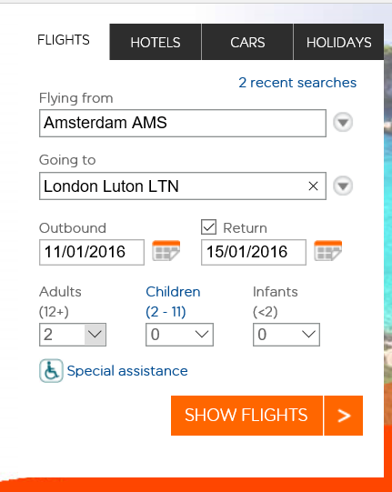

**You will find out what a return flight will cost to your chosen destination in the UK.**

* **You will fly from Amsterdam (AMS) to >your destination in the UK<**
* **Double check you have the correct dates**
* **The ticket is for two adults**
* **You have to book your flight from the Monday morning to the Friday afternoon**
* **Choose your best option**
* **Don’t forget to print screen!**

**Stap 3:**

**Ensure you write down all the details of the flight including showing your printscreen. Think about times, dates, prices, luggage and any additional things you might want to add.**

|  |
| --- |
| Details flights:  17oct. – 21oct. 2016  We will flight with KLM.  Flight from Amsterdam to Birmingham 8:45a – 8:55a  Flight from Birmingham to Amsterdam 5:30p – 7:45p  The flight will cost: 106,22 pound  *we can only bring hand baggage whit us |

Assigment 1: Print Screen Flights

Please paste your print screen of your flight information below

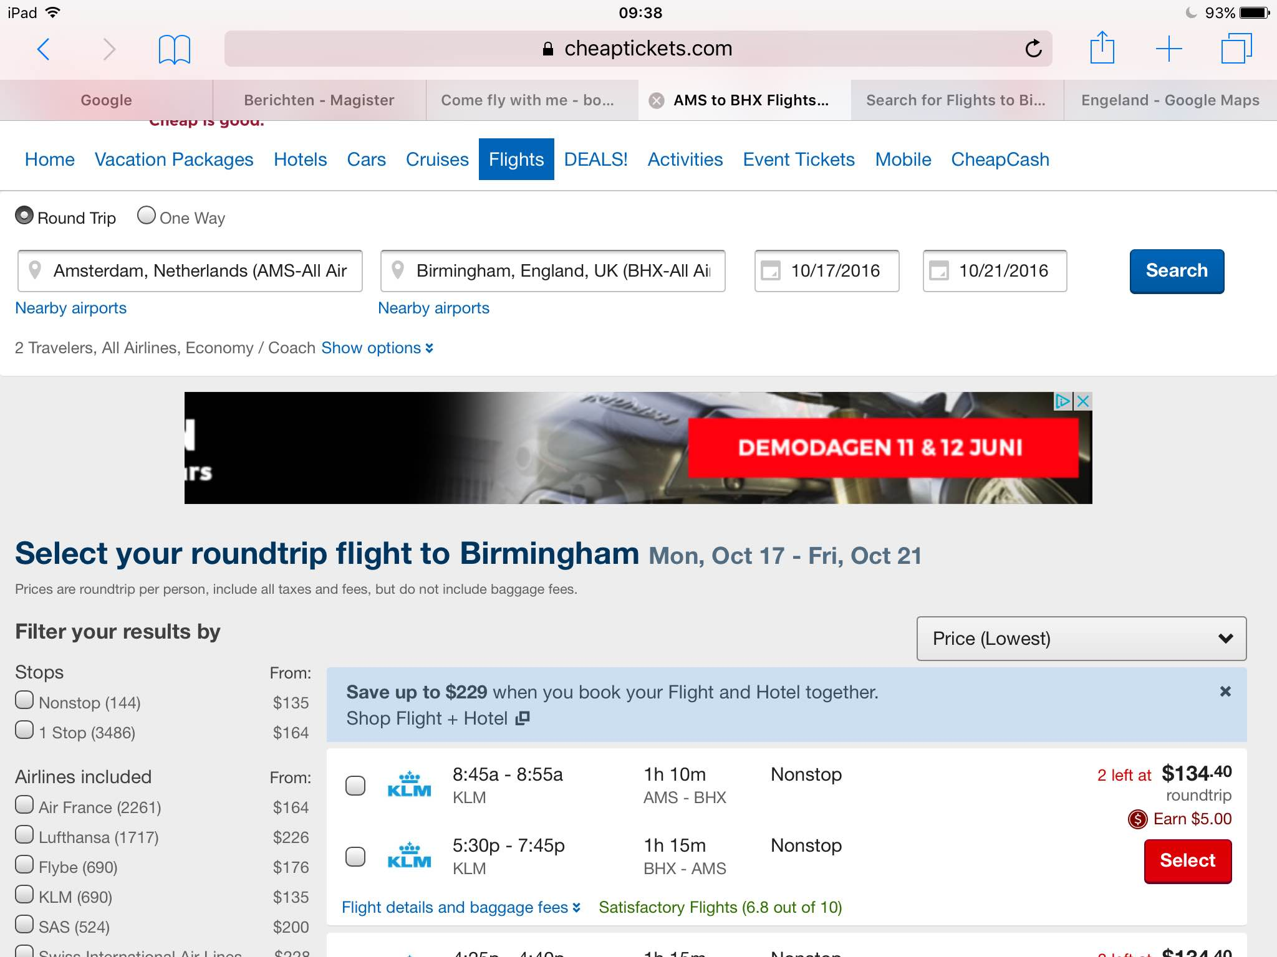Assignment 2: Book your stay

**Step 4:**

**In your previous assignment, you have chosen your flights to your destination. On top of going there, you will need a place to stay.**

**The minimum requirements are:**

* **It has to be one accommodation for the 4 nights you are there**
* **You need to include breakfast**
* **It has to be within your budget**
* **It has to have come from an English website**

**Tips for accommodation websites:**

* [**http://www.bedandbreakfasts-uk.co.uk/**](http://www.bedandbreakfasts-uk.co.uk/)
* [**http://www.bedandbreakfastnationwide.com/**](http://www.bedandbreakfastnationwide.com/)
* [**http://www.hotels.uk.com/**](http://www.hotels.uk.com/)
* **If you were to find another English website, that is allowed. Make sure you state your source!**

**Stap 5:**

* Write down the details of your accommodation, including dates, prices and facilities

|  |
| --- |
| Accommodation details:  Our hotel is: plough and harrow  We will check- in: oct.17 2016  We will check- out: oct.21 2016  Room 1: 2 adults  Total price: 360 pound |

Assignment 2: Accommodation

Please paste your print screen of your accommodation information below

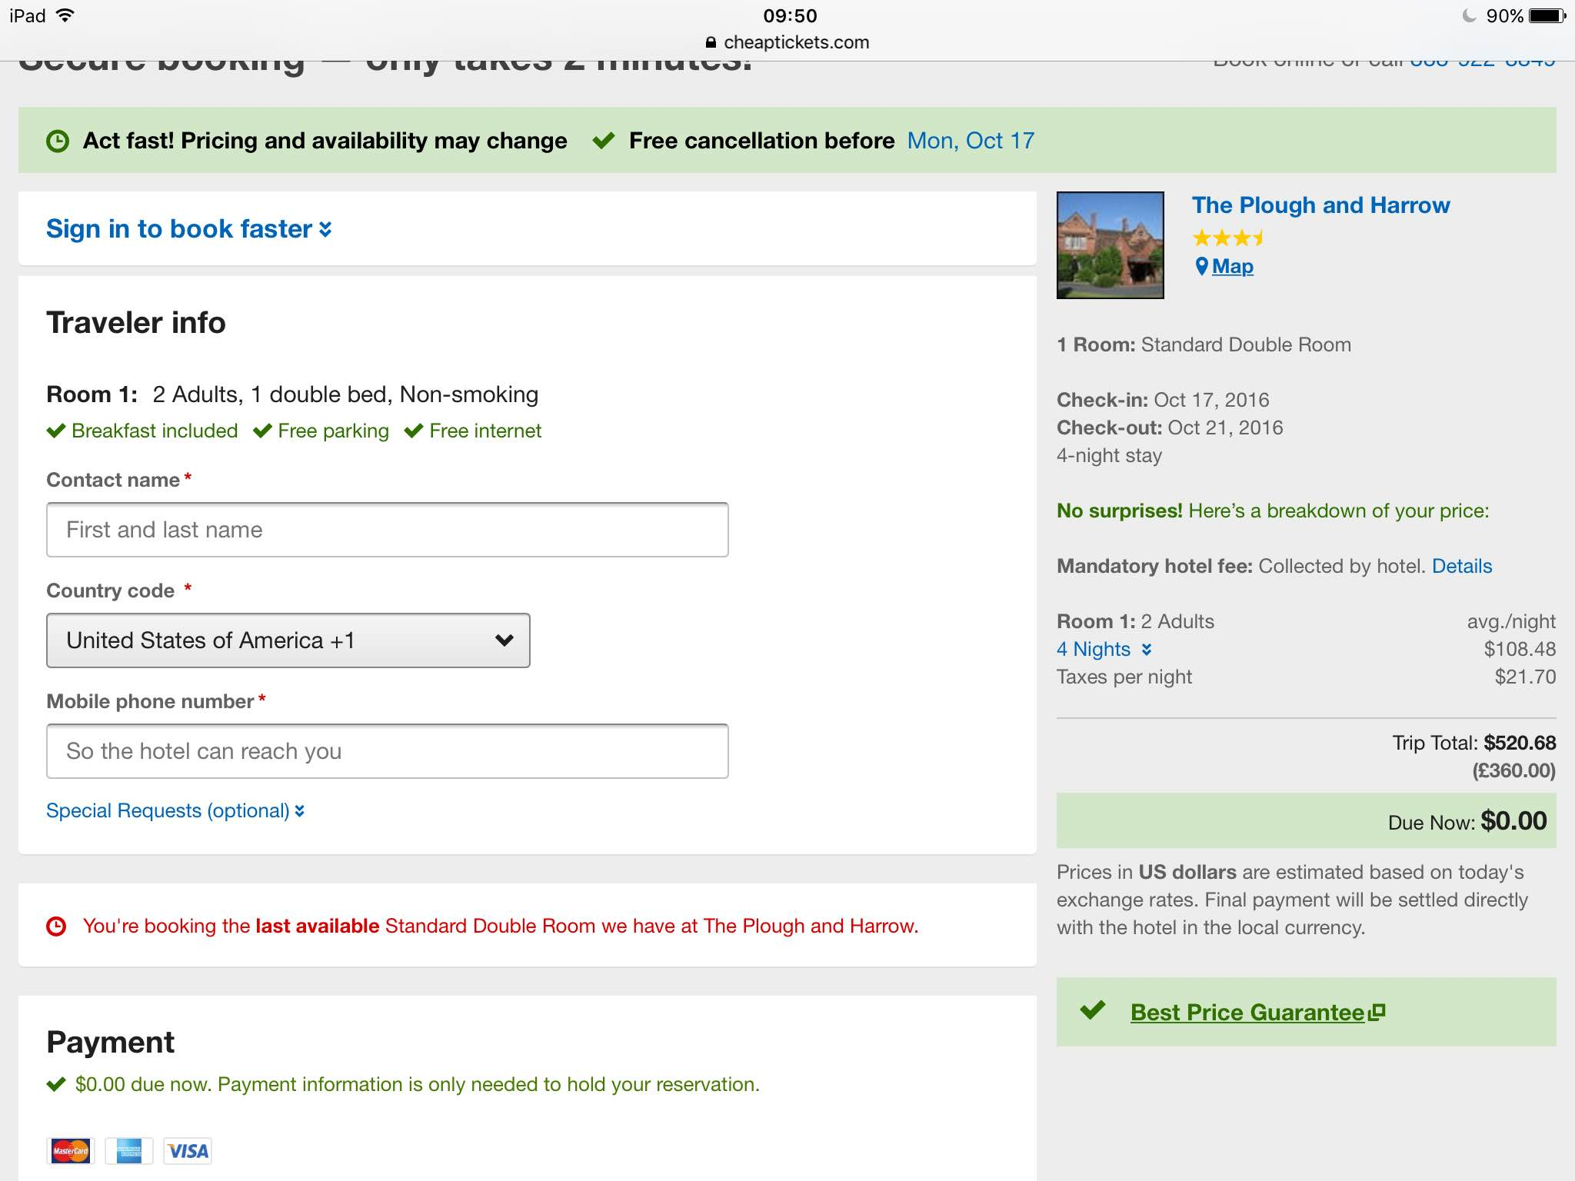

Assignment 3: What to do?

**Stap 6:**

You have booked your stay! Congratulations! However, you are a busy bee and would like to do something when you are there. After your arrival you will have to find a few activities. Please read below.

* **Day 1 (Monday):** your day of arrival. You will have a walk around your accommodation

and you will have to find a restaurant to eat at.

* **Day 2 (Tuesday):** visit to 1 activity
* **Day 3 (Wednesday):** visit to 1 activity
* **Day 4 (Thursday):** visit to 1 activity
* **Day 5 (Friday):** today is the end of your short break. See if you have any money and time left to do something.

**Please note!**

You are not allowed to visit the same activity twice!

**Activities could include:**

* Musea
* Events
* Gigs
* Theatre
* Anything the local ‘tourist office’ has to offer
* Any activity you would like to do whilst on holiday

**Be creative!**

|  |  |
| --- | --- |
| Day 1 | Activity: walk around accommodation  Place: Birmingham, plough and harrow  Description:  First we will have a walk and we will check- in, and we will eat supper at the restaurant of the hotel. The food will cost total: 29 pound |
| Day 2 | Activity: Justin Bieber show  Place: BarelaycardArena, Birmingham  Description:  The show costs 113,90 pound total. It’s just 20min. to walk, so we won’t go by car. |
| Day 3 | Activity: sea life  Place: Birmingham  Description:  It’s open from 10am – 5 pm.  Sea life is a place where you can see a lot of different sea animals we will go by walk, it’s just 15 min. to walk. |
| Day 4 | Activity: think tank museum and Adams restaurant.  Place: Birmingham  Description: it’s a museum about old planes. We can walk to the museum or we can go by car because we have enough money. After that we are going to one of the best restaurants in Birmingham. |
| Day 5 (optional) | Activity: flying back to Amsterdam  Place: Birmingham airport, and Schiphol  Description: we will leave at 5:30, and we will arrive at 7:45. |

Assigment 3: Activities

Please paste your print screens of your activities information below

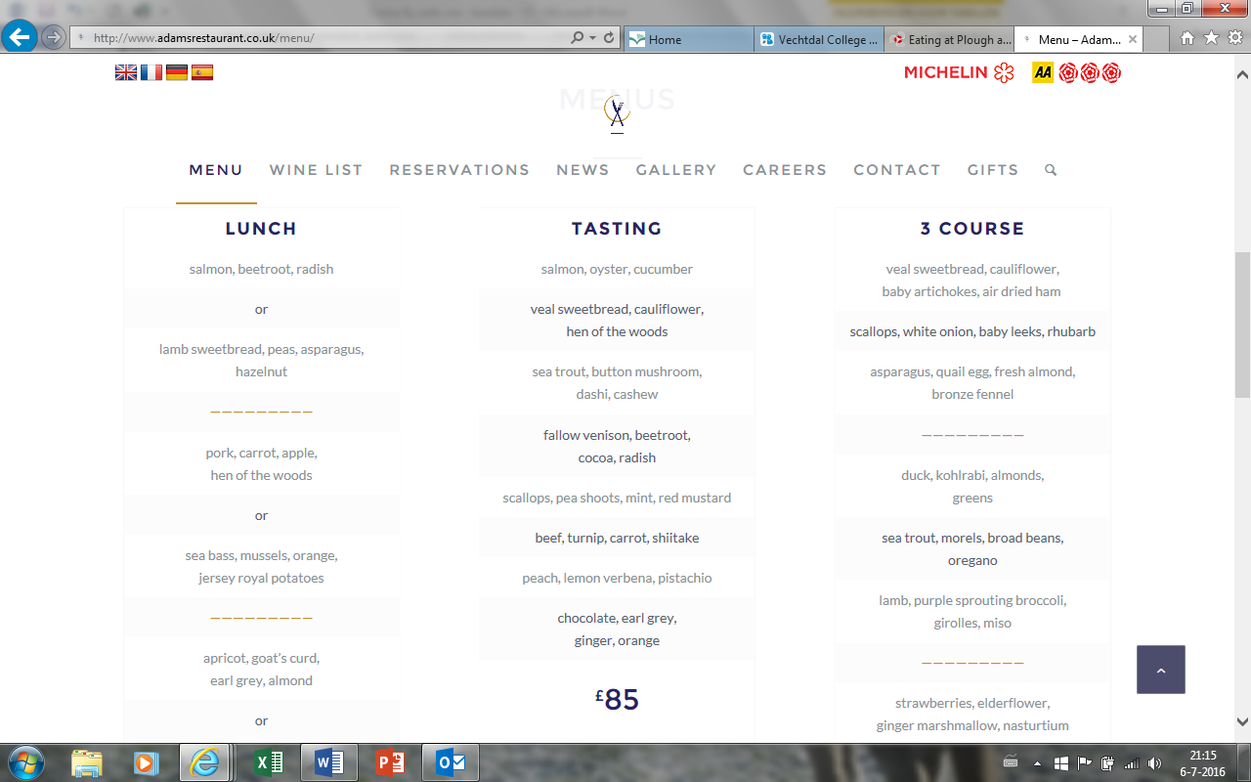

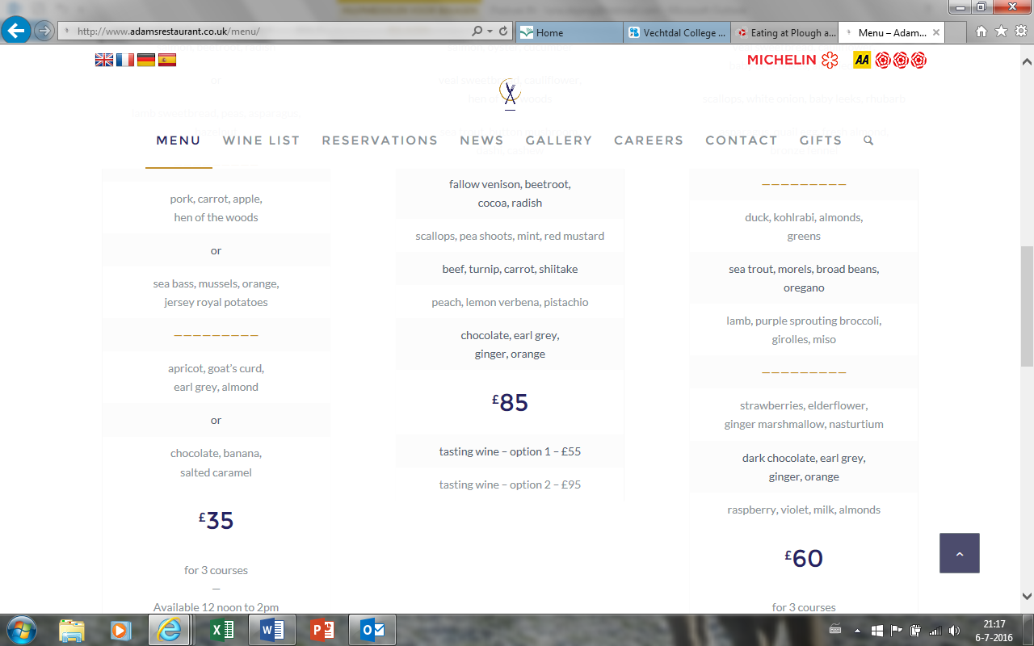

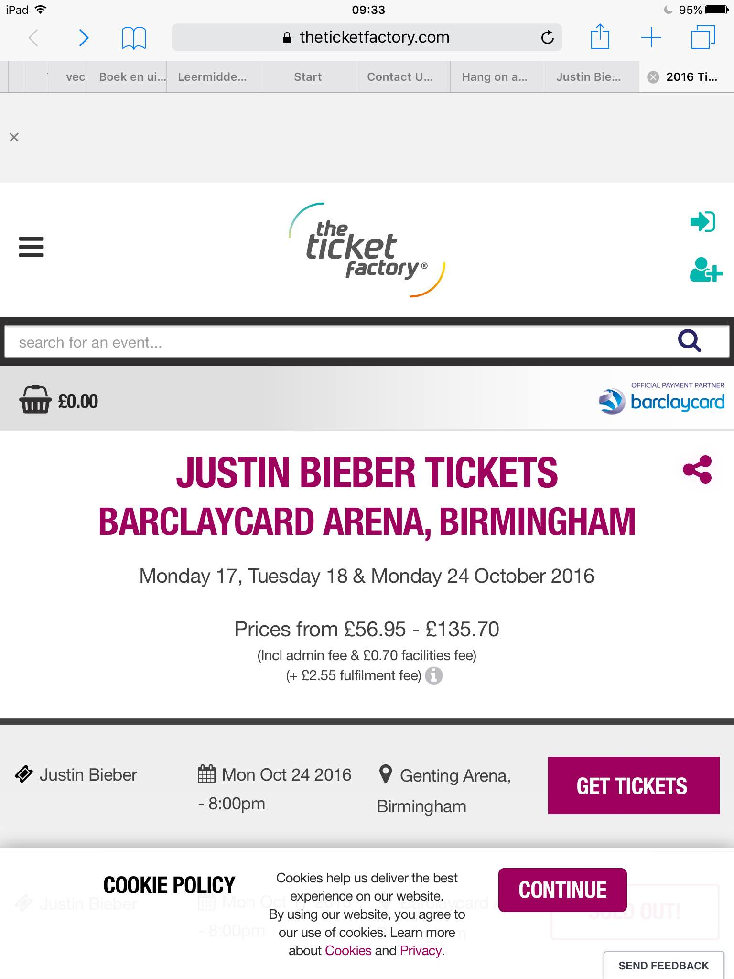

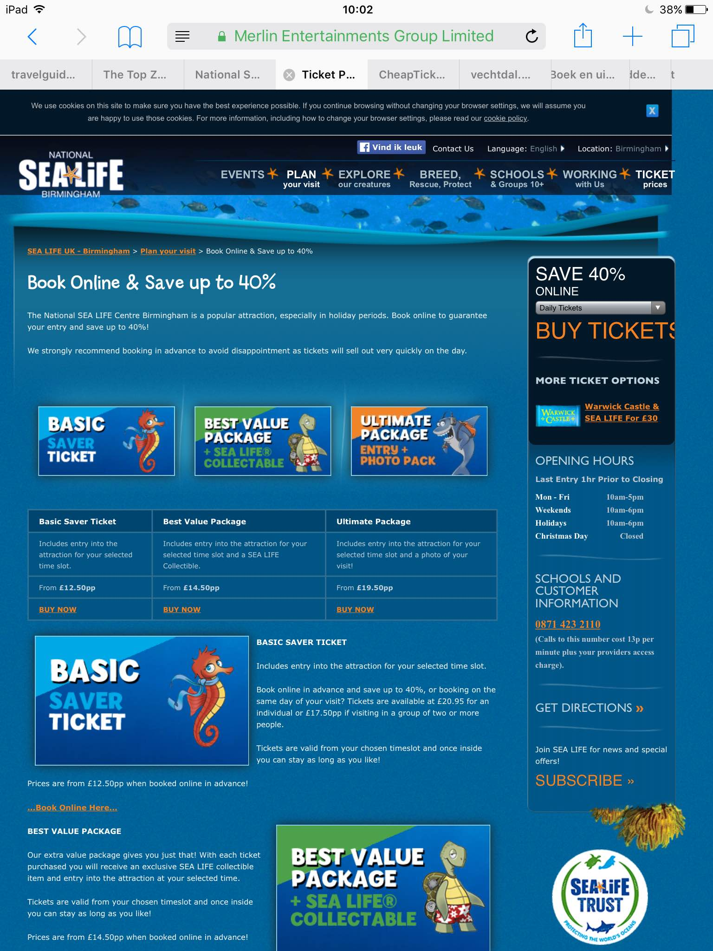

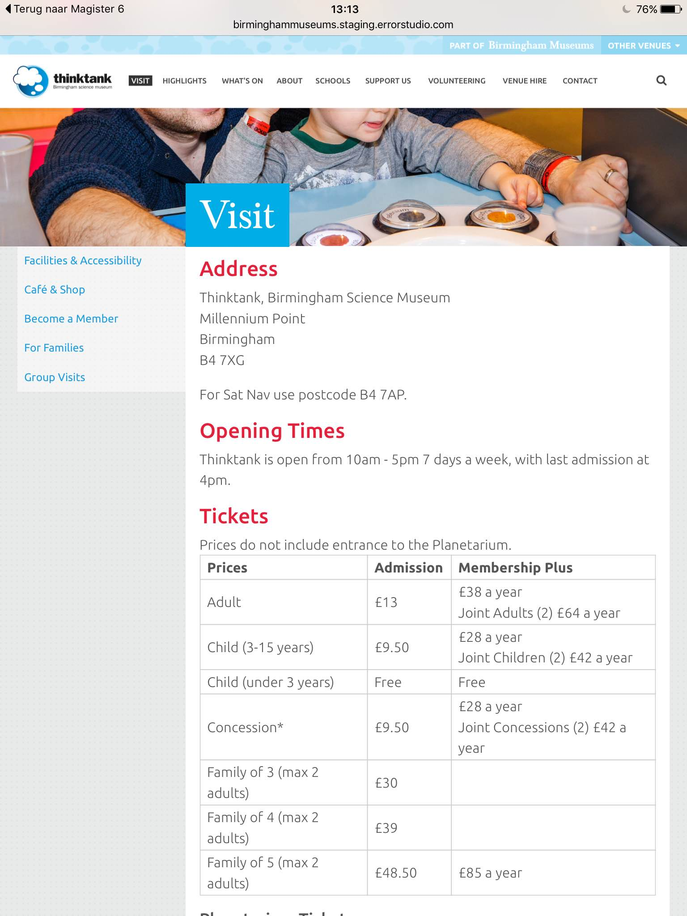

Assigment 4: Presentation

**Step 7:**

All of your information will now be gathered in a PowerPoint Presentation. Ensure it is a detailed description of your stay in the UK. And yes, it has to be in English.

Any questions, you know where to find me or email me via ELO/Magister.

Assignment 5: Personal Evaluation (pupil 1)

Name: Luna de Jong

Teacher: Miss. Klomp

Date: 5-7-2016

The tasks I contributed were:

We did the most things together. But I did the Word documents, but after I finished we have looked together at it, to see if everything was okay.

This is my opinion about the task and end result. Please explain.

I think that the result is very nice, and that we have worked very well together. I also think that Sifra did a lot of work on the powerpoint, but we did the most things together.

If you worked independent, please tell me what you found easy/hard/or what stood out for you.

If you worked together, please explain what you found easy/hard/or what stood out for you.

It was very hard to find any flights, but after a while we finally got something cheap. It was easy to find activity’s, but there were a lot of museums.

Give yourself a grade on a scale from 1 to 10 about the full project.

Naam: Luna de Jong 1 2 3 4 5 6 7 **8** 9 10

What did you think about the project and what could improve it?

Now I can finally book a flight, and I know how to find things on English sites.

Please grade the project assignments:

A trip to the UK! 1 2 3 4 5 6 7 8 **9** 10

Assignment 5: Personal Evaluation (pupil 2)

Name: Sifra Burger

Teacher: Miss. Klomp

Date: 5-7-16

The tasks I contributed were:

We did a lot of things together, but I did the powerpoint, and after I have finished that, we looked at it together. So Luna could tell if she didn’t like something, or she wanted to change things.

This is my opinion about the task and end result. Please explain.

I think we did a really good job together, I really liked working together with Luna. The result became very nice, I think.

If you worked independent, please tell me what you found easy/hard/or what stood out for you.

If you worked together, please explain what you found easy/hard/or what stood out for you.

It was also very hard for me to find any flights. The project was a lot of work, but it wasn’t to hard for me, i really liked the things that I have learned from this project.

Give yourself a grade on a scale from 1 to 10 about the full project.

Naam: Sifra Burger 1 2 3 4 5 6 7 **8** 9 10

What did you think about the project and what could improve it?

I think that this project is very good for us to do, because one day if you want to go to England or an other country, you need to know how you can find things. So I have learned a lot of things about it.

**Please grade the project assignments:**

A trip to the UK! 1 2 3 4 5 6 7 8 **9** 10